**AWS IAM Assignment**

1. Create a new IAM user with programmatic access only and generate an access key and secret access key.

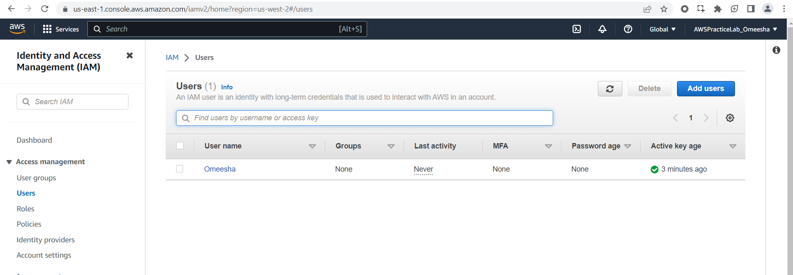

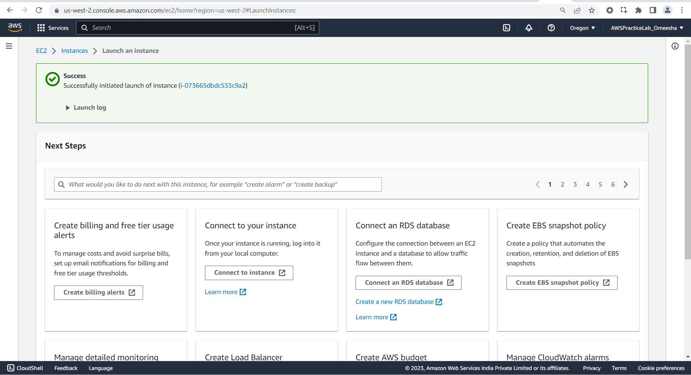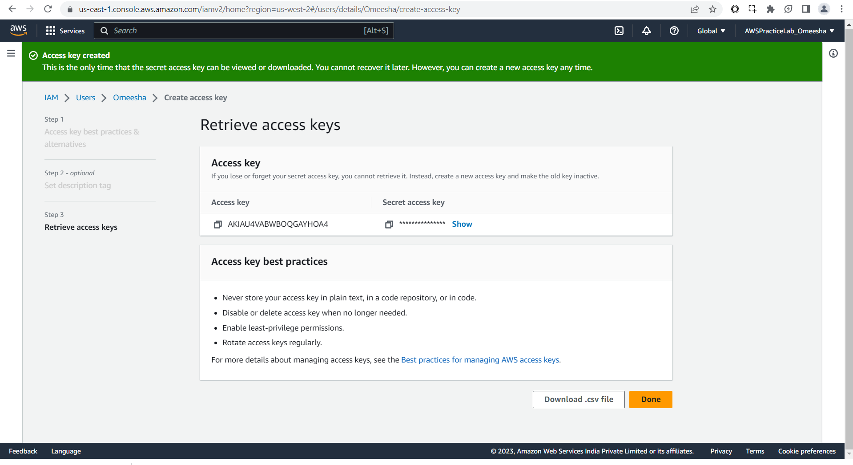

1. Create an IAM policy that allows the user to read and write to an S3 bucket and attach it to the user.

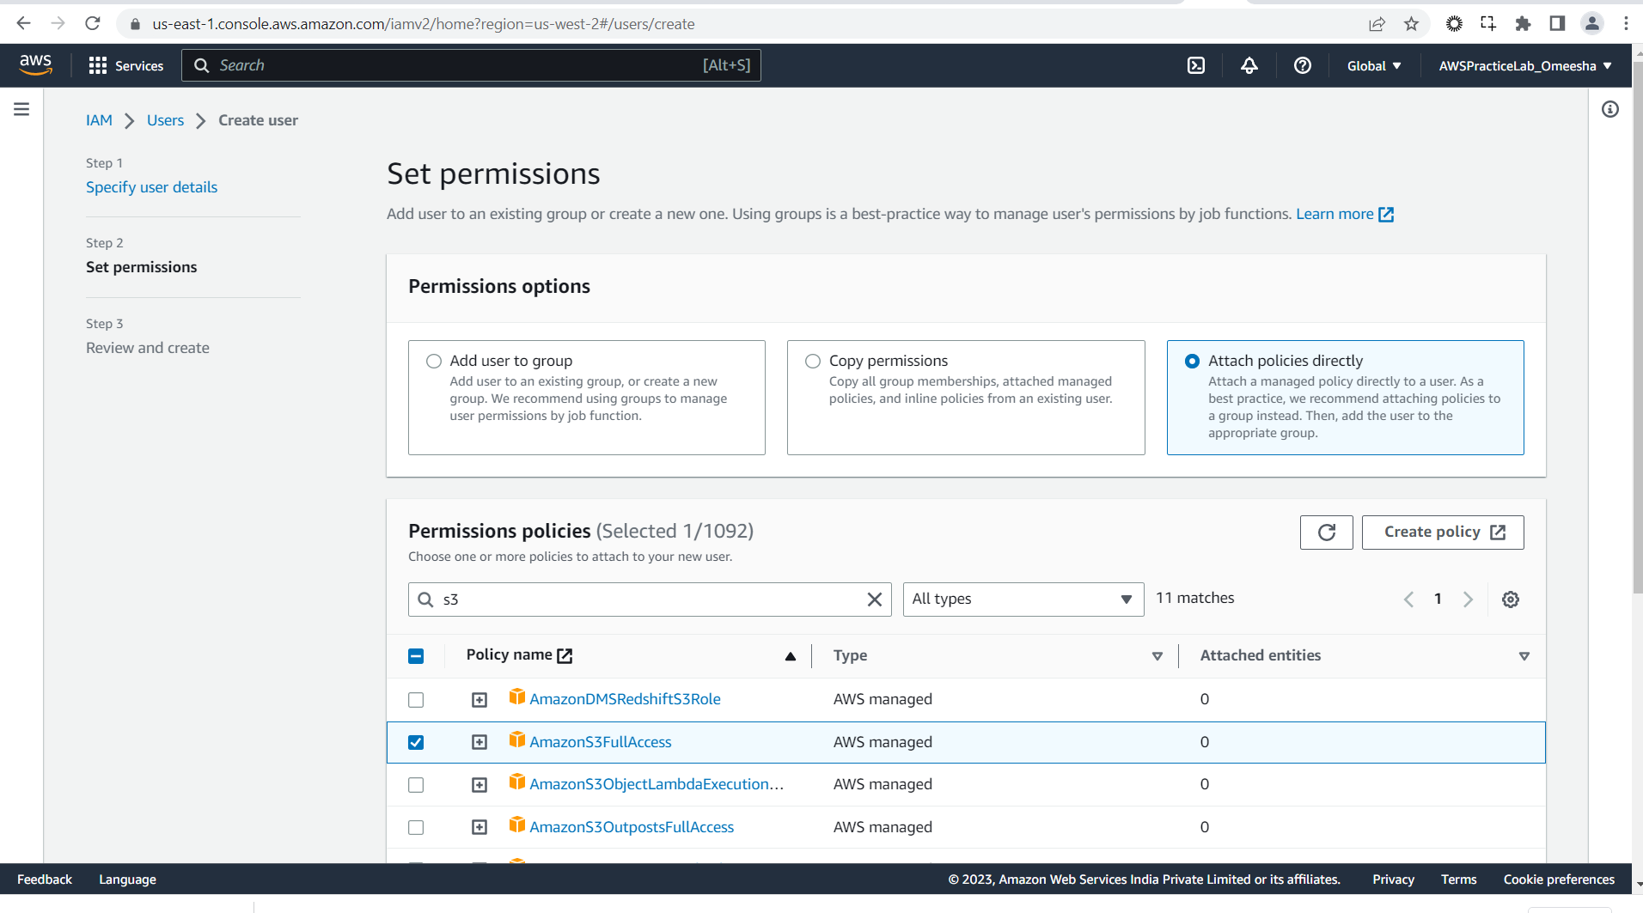

Create bucket

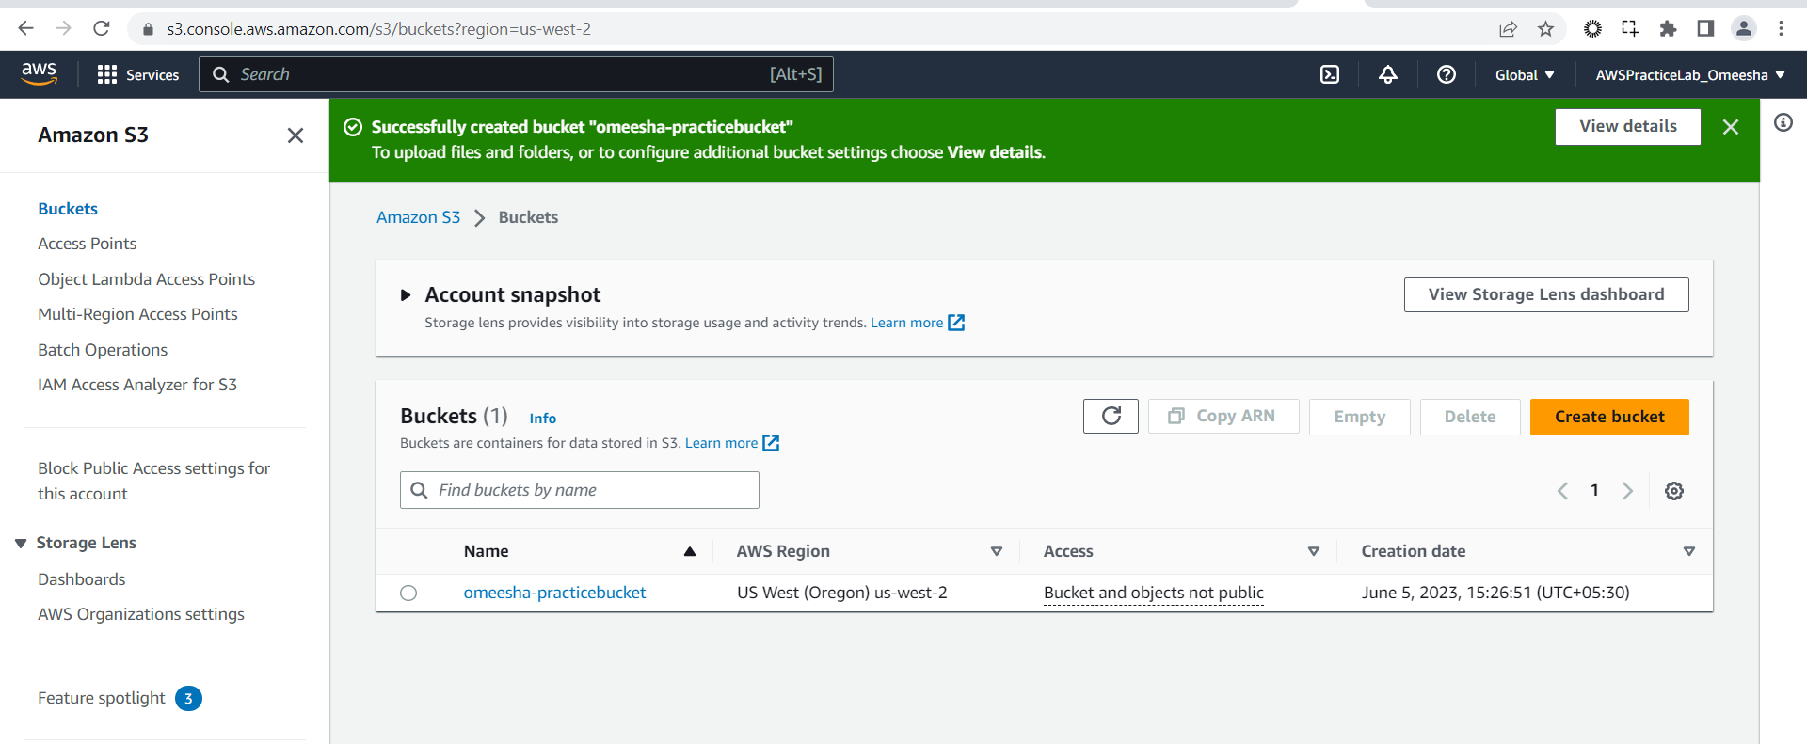

Copy bucket ARN

Go To policy generator

<https://awspolicygen.s3.amazonaws.com/policygen.html>

|  |
| --- |
| {  "Version": "2012-10-17",  "Statement": [  {  "Sid": "Stmt1685959661822",  "Action": "s3:*",  "Effect": "Allow",  "Resource": [  "arn:aws:s3:::omeesha-practicebucket",  "arn:aws:s3:::omeesha-practicebucket/*"  ]  }  ]  } |

Copy the generator policy and go to IAM

<https://336416845917.signin.aws.amazon.com/console>

OmeeS3-TestUser

kC6=a*Z0

Open a separate browser

Able to login with the new user

Copy S3 bucket url

https://s3.console.aws.amazon.com/s3/buckets/omeesha-practicebucket?region=us-west-2&tab=objects

1. Create an IAM group and add the user to it. Launch an EC2 instance and assign the IAM role to it.

1. Create an IAM policy that allows read-only access to an S3 bucket and attach it to a group.

1. Create an IAM policy that denies access to an S3 bucket and attach it to a user, group, or role.

